**How to see cloud data from fmi PLUS estimated power calculations**

Link to FMI XML file:

<http://opendata.fmi.fi/wfs?service=WFS&version=2.0.0&request=getFeature&storedquery_id=fmi::forecast::hirlam::surface::point::multipointcoverage&place=vaasa&parameters=TotalCloudCover>

Download the XML document/file from URL above

* Open the link
* Right click
* Save page as
* Save as “xml file.xml” (something.xml)
* Save somewhere convenient

Test XML file

* Open XML file in notepad++ (or similar program)
* Copy entire XML text file (Push ctrl + a and then push ctrl + c)
* Open <https://www.freeformatter.com/xpath-tester.html#ad-output>
* Paste (ctrl + v) xml file here

* Write “//gml:doubleOrNilReasonTupleList” here

Test result e.g.

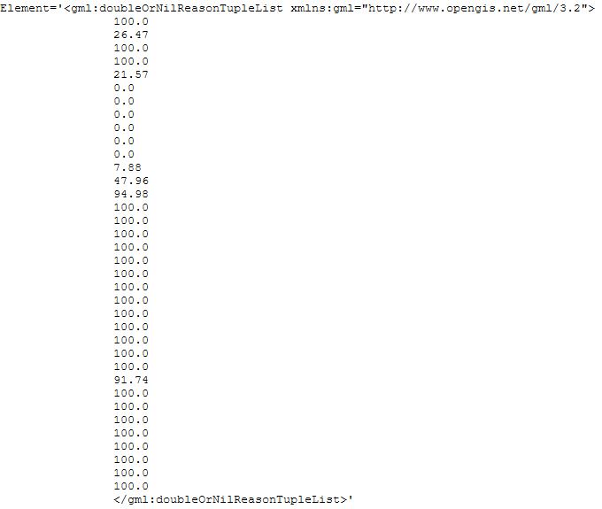

Each number is cloud data for one hour -> cloud data for the next 36 hours

Time test for the first 4 times:

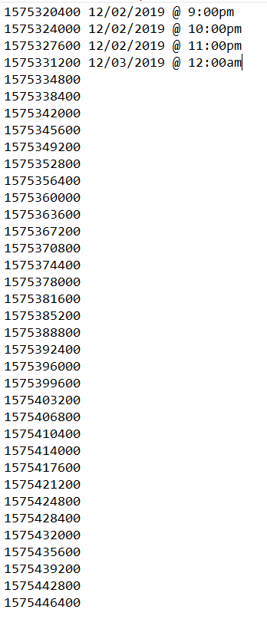

Location and time data

* Open xml file in notepad ++
* Push ctrl + f
* Write “<gmlcov:positions>” here

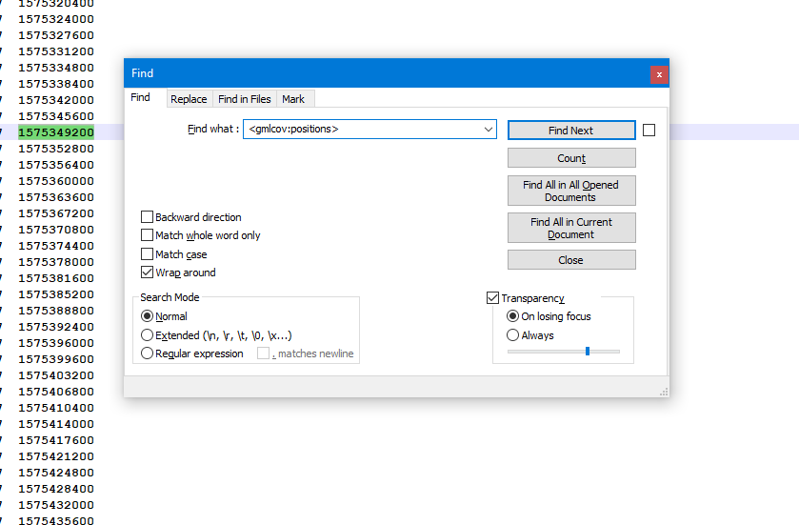

* Click “Find next”
* You will find something like this

* Format -> longitude latitude time
* Example 63.09600 21.61577 1575320400
* Time is in “unix” (unix timestamp)
* To see location copypaste location into map service (e.g. Google maps)



* To see time, open https://www.unixtimestamp.com/index.php

copypaste time here

* Example time is 1575352800 in unix

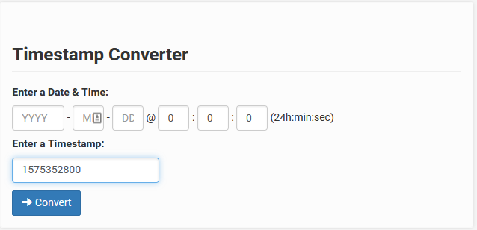

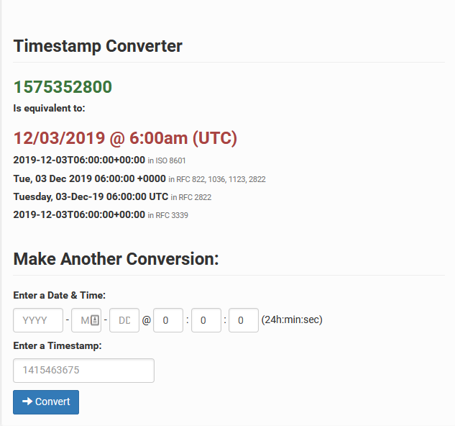

**Basic calculations for Solar Plant production:**

Solar Power plant is 5 kw -> max production

Power production is 100% between sun rise and sun set

**Sun rise sun set** <http://www.moisio.fi/taivas/aurinko.php?paikka=Vaasa&dy=26&mn=11&yr=2019>

**Formula:** ( 1 - cloud data) times max production

If cloud data for one hour is 100, then production is 0

If cloud data for one hour is 75, then production is (1- 0,75) * 5 kw = 1,25

If cloud data for one hour is 50, then production is (1- 0,50) * 5 kw = 2,5

If cloud data for one hour is 25, then production is (1- 0,25) * 5 kw = 3,75

And so on...

If we have time ->

**Advanced calculations for Solar Plant production:**

Same as in basic calculations but max production is (5 kw in basic calculations) max production for past years